**Brooklyn torah gazette**

**For parshas pinchas 5781**

Volume 5, Issue 46 (Whole Number 246) 23 Tammuz 5781/ July 3, 2021

**Printed L’illuy nishmas Nechama bas R’ Noach, a”h**

For a free subscription, please forward your request to [***keren18@juno.com***](mailto:keren18@juno.com)

**A Mother’s Lifesaving Rejection of Her Son**

**By Rabbi Yoseph Geisinsky**



**Rabbi Yoseph Geisinsky**

This past Sunday, June 27, 2021 was the fast day of the 17th of Tammuz. It was the day that the walls of Jerusalem were breached by the Babylonians in 586 BCE, enabling the enemy's conquest of the holy city, leading to the destruction of the Holy Temple three weeks later on the 9th of Av.

What is the mindset to enter into this period

**A Gripping Autobiogrpahy**

Let me share a story, recorded in the gripping autobiography of Rabbi Lau, Out of the Depths. When Rabbi Lau, former chief rabbi of Israel, shuts his eyes and recalls his childhood, his mind is crowded with images of trains, of boots pounding on the pavement, of barking dogs. He hears children wailing, "Mamme! Tatte!" as they are torn from their parent's arms, the Gestapo screaming, "Schnell, schnell!" as they wield their clubs, and always, the dogs barking.  
 "Lulek," as Rabbi Lau was then called, was two years old when the Second World War broke out, and eight when he was liberated from Buchenwald.  
 Rav Yisroel Meir was born on 1 June 1937, in the Polish town of PiotrkÃ³w Trybunalski. His father, Rabbi Moshe Lau, was the last Chief Rabbi of the town; he was sent with another son, Shmuel, to the Treblinka extermination camp, where they were gassed.

The father’s last instructions to his sixteen-year-old son Naftali were to protect his little brother, Lulek, to ensure that the Rabbinical chain remains unbroken. Their mother also died in the camps two years after her husband.

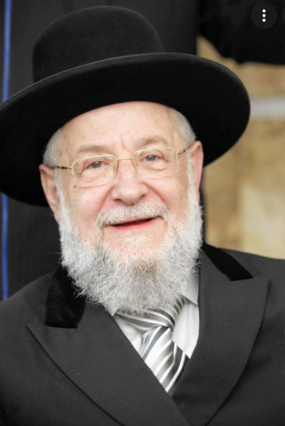**Rabbi Yisroel Meir Lau**

"I was separated from my mother in November 1944," says Rav Lau. "I can still hear the Germans yelling 'Schnell, schnell!' as they crowded us onto the train platform. My brother Naftali, who was eighteen, had been put with a group of men, and I was with my mother. Women and children were being shoved into one freight car, men into another.

**A Hard Shove from His Mother**

"At the last second before boarding the train, my mother gave me a hard shove over to the men, whom she hoped would be used for labor and not killed. 'Tulek!' she called to my brother. 'Take Lulek! Goodbye, Tulek! Goodbye, Lulek!'  
 "I never saw her again.  
Never in my short life had I cried like that, and never in all the long years since then. It took a long time until I understood that by pushing me away like that, my mother had saved my life."

**Ended Up in Buchenwald**

He ended up in Buchenwald. His brother smuggled him into the camp in a sack. And Lulek survived.  
 Rav Lau once shared his memories when the Americans have arrived and Buchenwald was liberated. "I remember the looks of horror on the faces of the American soldiers when they came in and stared around them. I was afraid when I saw them. I crept behind a pile of dead bodies and hid there, watching them warily.

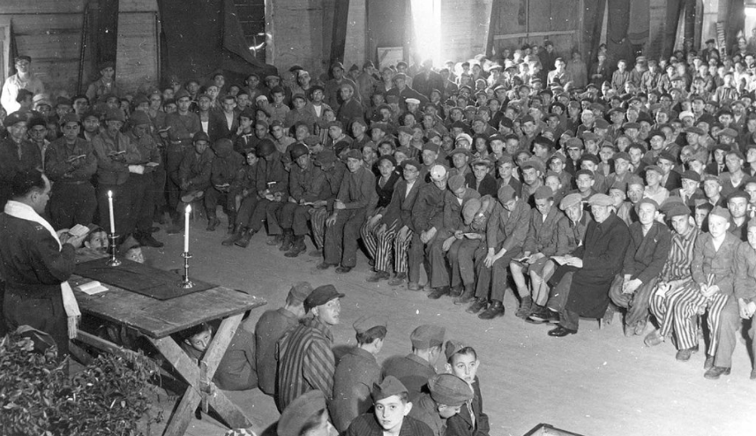

**American chaplain Rabbi Herschel Schacter conducts religious services at the liberated**[**Buchenwald concentration camp**](https://en.wikipedia.org/wiki/Buchenwald_concentration_camp)**in 1945.**

"Rabbi Herschel Schachter was the Jewish chaplain of the division. I saw him get out of a jeep and stand there, staring at the corpses. He has often told this story, how he thought he saw a pair of living eyes looking out from among the dead.

It made his hair stand on end, but slowly and cautiously he made his way around the pile, and then, he clearly remembers coming face-to-face with me, an eight-year-old boy, wide-eyed with terror. In heavily-accented American Yiddish, he asked me, 'How old are you, mein kind?' There were tears in his eyes.  
 "'What difference does it make?' I answered, warily. 'I'm older than you, anyway.'

"He smiled through his tears and said, 'Why do you think you're older than me?'

"And I answered, 'Because you cry and laugh like a child. I haven't laughed in a long time, and I don't even cry anymore. So which one of us is older?

**Photo of the Suitcase**

There is a photo that is framed and hangs on the wall for all to see as they enter Rabbi Lau’s home. It's the famous photograph of a smiling, eight-year-old Lulek, a coat draped over one arm, the other holding a suitcase.

"An American soldier donated an old suitcase to me from the army surplus storehouse. It went with me to Israel, and it held everything I owned, as I wandered from one educational institution to another. By the time I got married, it was so shabby that my wife wanted to throw it out, but I refused to part with it.

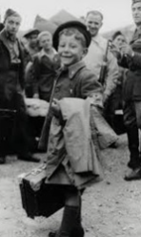

**Young Yisroel Meir with his suitcase upon landing in Israel**

'This was my house,' I told her. 'If our children ever complain, I'll show it to them and say, "This is what your father had when he was a boy." I put it up in the storage loft of our building, and when we moved to another apartment, I came back for it. I climbed seventy-five steps to retrieve it, but I found nothing there but the handle. The suitcase had disintegrated.

**Elie Wiesel Found the Photo**

"But I have the photo. Elie Wiesel, who was with me in Buchenwald, presented it to me at an event; he'd spotted it in a museum in Vancouver. It came as a complete surprise to me. As soon as the children saw it, they all said, 'There's the suitcase!'

"When I leave my house every day, on one side of the door is the mezuzah; on the other side is this photograph. Each time I see it, it says the same thing to me: Yisrael, look at Lulek. Now your task is to justify the fact that you were saved. You must carry out your parents' mission; you must keep the chain unbroken. This is from whence you came."  
 "And across from the photo, the mezuzah tells me 'before Whom I'm destined to give an accounting."

*Reprinted from the Parshat Balak 5781 email of Chabad of Great Neck (NY).*

**Rabbi Berel Wein**

**On Parshat Pinchas**

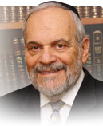

There were extremely negative murmurings within the people of Israel in objection to the actions of Pinchas for his zealousness in slaying Zimri together with the lecherous princess of Midian, Kozbi bat Tzur. Many attributed the violence of his act to the fact that his mother that his mother was a Midianite and that he was descended from a priest of Midian himself.

There are those amongst us who abhor violence at all costs, in all circumstances. There is no such thing as a justifiable homicide as far as they are concerned. Human life is so precious that even the most evil of people must be protected so that no harm should befall them. Apparently, these murmurings against Pinchas, the grandson of Aharon, who was the most beloved of all leaders of the Jewish people, were so strong that the L-rd had to "intervene" to defend Pinchas and highlight the justification and necessity of his act.

In theory, pacifism is a noble idea. However, the contentious and dangerous world that human beings are forced to live in becomes a certain recipe for disaster, and the triumph of tyranny and evil. Justice is a messy business to put into practice. The effect of the immorality of Zimri on the general Jewish society was so detrimental that the L-rd indicates that a plague of enormous consequences would have been loosed on the Jewish people were it not for the actions of Pinchas.

One of the basic questions in ethical literature, and it appears as a basic question in Halacha, debates the morality of sacrificing one's life in order that many lives will be saved and spared. It is not my purpose in this article to develop this into a complex issue, but to point out that in this very instance, a moral dilemma of human beings was addressed by the statement of the L-rd in defense of the actions of Pinchas.

Nevertheless, even with the apparent endorsement of Heaven for this act of zealotry, Judaism shies away from all forms off fanaticism. There is no other person in the holy writings of Scripture whose zealotry is condoned by Heaven. In fact, a great prophet Elijah is rebuked by Heaven itself for the zealotry that he displayed against the Jewish people.

There is no question that the people were sinners and idolaters, and we can feel and empathize with the pain and loneliness of Elijah, seeing how disastrously Israel had wandered from their core beliefs and mission. Nevertheless, Elijah is instructed that until he removes that attitude of zealotry from his relationship with the people of Israel, he cannot remain the instrument of G-d's will to communicate with Israel.

At that moment in his life, Elijah is transformed from an avenging angel into the angel of generational covenant, the messenger of the tidings of redemption, and the comforting presence that has accompanied the Jewish people throughout the world over its long and painful journey of exile. So, we are brought full circle in dealing with vengeance and zealotry, and we are reminded not to be unrealistic pacifists at the same time.

*Reprinted from the current website of rabbiwein.com*

**Parshas Pinchas**

**The Responsibilities of a Jew**

**By Rabbi Bentzion Shafier**

**Founder of TheSmuz.com**



“*Pinchas, the son of Elazar, the son of Aharon HaKohain, appeased my anger against the Bnei Yisroel by taking My revenge amongst them, and now I do not have to destroy the Bnei Yisroel in My vengeance*.” — Bamidbar 25:11

**The Death Knell of Amon and Moav**

The nation of Moav heard about *Bnei Yisroel* coming, and they were seized with fear. For many years, they had known “all that HASHEM had done for the Jewish people while taking them out of Mitzrayim,” and they were well aware that the land of Israel was consecrated for the Jews. Now the inevitable was coming to fruition.

Recognizing that there was little hope in waging war against the Jews, Balak, the king of Moav, hired Bilaam to curse the Jews. However, not only didn’t Bilaam curse the Jews, he gave them a *bracha*, saying the prophetic words: “*Ma tovu ohalecha Yaakov.*” When Balak confronted Bilaam about this, Bilaam’s truthful response was, “It is not in my power to curse them. But if you want advice in fighting this nation, you must get HASHEM to be angry with them. Their G-d hates promiscuity. If you can get them to sin, you can conquer them.”

With that was launched a fatal attack against the Jews. Balak sent out the *Bnos Moav* to entice the Jewish men. The plot was successful and thousands of Jewish men succumbed. At the height of the debacle, Zimri, the head of *Shevet* Shimon, took a Moabite woman into the very camp of Israel and publicly committed a sin with her.

When Pinchas saw this, he stood up, and at the risk of his life, miraculously killed them both.

After the events, the *posuk* describes HASHEM saying, “ Pinchas took my revenge amongst the people, and now I do not have to destroy the Jewish nation.” The *Siforno* explains that because the entire nation saw what had transpired and didn’t act, they all deserved to die. By acting in public for all to see, Pinchas atoned for their sin, and now HASHEM didn’t have to kill out the nation.

**Two Difficulties with the Siforno**

This *Siforno* is difficult to understand on two levels. First, what was the sin of the Jewish people? They weren’t accused of doing acts of immorality. Their “crime” was in not protesting an act done in their midst. Where do we see that the punishment for not giving rebuke is death?

Even more troubling is what seems to be a grave inequity. If Pinchas had not killed Zimri, then HASHEM would have had to wipe out an entire nation. Pinchas’s act of killing one man evened out the score so that now the death penalty against the generation didn’t have to be carried out. How does killing one man equal the death of millions?

The answer to this question can be best understood with a *moshol*:

**In the Royal Throne Room**

Imagine that you are in the royal throne room when a commoner enters and requests an audiencewith the king himself. The monarch in a very generous act grants the request. The peasant then asks for even more. He requests permission to step forward and whisper something highly confidential into the king’s ear. The monarch charitably grants even this appeal. The commoner steps forward, leans over, and with a resounding smack, slaps the king squarely in the face. The guards jump forth and grab him. Every person in the throne room is in utter shock and disbelief. The affront to the king is appalling. Such an act in the royal chambers to the king himself is an affront beyond description.

There is little question that this person has lost his lease on life. Likely, he would be killed on the spot.

Let’s take this same scenario but instead of a commoner, it is the king’s son who hits him. Now the affront is increased dramatically. Not only was such an act committed, but it was done by nobility, by someone respected in the kingdom, by someone who is expected to love and honor the king. The affront would now be outrageous.

To fully appreciate the gravity of what was happening in Zimri’s time, we need to add one more dimension. Imagine that at the time of the act, the entire royal family was gathered for an affair of state. All of the sons and daughters of the king together with their spouses, the king’s brothers, and their children are there. Included are the dukes and earls, the ministers and advisers — the entire assemblage representing all of those who love and support the king.

**No One Defends the Honor of the King**

The king’s son stands up, walks to the throne and sharply smacks the king. Then he sits back down in his seat — and no one says anything. Not a single royal responds. No one protests. No one comes to defend the honor of the king. Now this situation has intensified exponentially. Not only is the affront itself dramatic, the marked silence of the king’s friends is even worse. How can you not speak up? How can you not defend the honor of the king?

This seems to be the answer to the question. When Zimri publicly committed this sin, it was a colossal affront to the honor of HASHEM. He was a *nasi*, one of the leaders of the generation. For such a man to commit this crime was horrific, but the silence of *Bnei Yisroel* was even worse. How is it that no one protested? Wasn’t there even one person loyal to HASHEM? Isn’t there even one individual who will defend the king’s honor? The *chillul* HASHEM was beyond description, and every person standing there was a part of it and made it even worse.

By Pinchas standing up and acting, not only was he defending the honor of HASHEM, he was taking off a powerful claim against the entire nation. Before Pinchas acted, every person there was a part of the silent majority, and by tacit agreement were part of the *chillul HASHEM*. Now that Pinchas stood up to defend the honor of HASHEM in front of them, they became inactive participants in that act as well, and so they were redeemed.

**A Member of the Royal Family**

This concept is very relevant to us in realizing what it means to be a Jew. By dint of being born Jewish, a child now enters the ranks of HASHEM’s people. We represent HASHEM; we are His Chosen Nation and His children. That comes with tremendous rights and responsibilities. When a Jew acts in a manner that is proper, it brings great honor to the King, and that person is rewarded accordingly. However, when a Jew acts in a manner not befitting his station in life, it isn’t considered the act of one individual, it is the act of a representative of HASHEM himself, and that single action becomes magnified many times over. When that act is done in public, there are two issues to deal with: the act itself and the reaction of those witnessing, especially if those around are themselves of royal lineage.

One of the most fundamental obligations of a Jew is in *kiddush HASHEM*. By acting as the Torah directs us, we bring more honor to HASHEM. By acting in a manner that is inappropriate, we bring dishonor to HASHEM. Because we are children of HASHEM, what we do reflects onto HASHEM. This greatly magnifies the significance of our every move. When we recognize our royal lineage, we can understand our great potential to accomplish as well as the grave responsibilities we have in life.

*Reprinted from this week’s website of Theshmuz.com.*

# Rav Avigdor Miller on

# Bungalow Marriages



**QUESTION: Should a husband and wife separate in order to go to the country in the summer?**

**ANSWER:** In general, a husband and wife should never separate. That’s the purpose of having a wife and having a husband. והיו לבשר אחד – And they will become one flesh (Bereishis 2:24). You don’t separate from your hands or from your feet. You have to realize that it’s one personality. It’s not just a team, it’s a personality. They must always be together.

Now, it doesn’t mean that when he goes to the synagogue that she has to be in the background. Or that when she’s going, let’s say, to the sewing club, that he should hang around and look on, no. Each has his or her separate interests, but in general, they’re together.

Sometimes, he has to go away on a trip for work; he can’t take her along, it can’t be helped. A woman, however, just to go off on a pleasure trip someplace without her husband, that’s not to be recommended at all. Unless she has to go for certain business that the husband cannot go along. Let’s say, she has to go for some purpose, she can’t remain behind. And he has to remain here because of his business, that’s something else. But just for the sake of pleasure to separate, that’s against the principles on which marriage is founded.  
TAPE # 508 (June 1984)



**QUESTION: Is it proper this bungalow style vacation where the wife sees her husband only on Shabbos?**

**ANSWER:** And the answer is, if it’s a benefit for the children then it’s proper. Because עמלנו אלו הבנים – All of our work is our children. If the children in the bungalow can have a better environment than in the city, if they can have a very good rebbe, and very good chaveirim or chaveiros, then it’s worth it.   
 The only criterion is how much ruchniyus will the children gain. And on that basis this kind of arrangement is justified.

*Reprinted from the June 18, 2021 email of Toras Avigdor. Adapted from Tape #517 (August 1984)*

**An Etenal Lesson from the Righteous Jewish Women**

**From the Talks of the Lubavitcher Rebbe**

**Rabbi Menachem Mendel Schneerson, Zt”l**

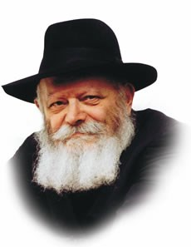

In this week's Torah portion, Pinchas, an incident with the five daughters of Tzelafchad is related. Tzelafchad, a Jew who died in the desert, had no sons. Since sons, and not daughters, were entitled to an inheritance, the daughters of Tzelafchad were not permitted a portion in the Holy Land.

The daughters of Tzelafchad, who were all known to be righteous women, objected to the thought that their family would not have a part in the Land of Israel. They went before Moses who presented the case to G-d. G-d said to Moses, "The daughters of Tzelafchad have a just claim. Give them a hereditary portion of land alongside their father's brothers."

This episode is just one example in the Torah of the relationship of the Jewish women to the Land of Israel. Another instance was when the spies returned from the land of Canaan with reports of fortified cities, armies, and giants. The men decided to turn back to Egypt. But the women remained steadfast in their desire to enter the land. Consequently, only the men of military age were punished; they were to die in the desert. The women, however, entered the Land.

In our Torah portion, too, we see the Jewish woman's love for the Holy Land. The task the daughters of Tzelafchad had set for themselves was not easy. The established judicial system was comprised of judges over fifty people, one hundred, one thousand, etc. The daughters of Tzelafchad had to approach various judges, each one referring the matter to higher authorities, until it was finally brought to Moses, himself. Tzelafchad's daughters were willing to try to overcome such a seemingly impossible obstacle to receive their portion.

This incident can serve as a lesson to each one of us in our daily lives, too. G-d demands that we conduct our lives according to certain guidelines. Yet at the same time, He created and organized the universe in such a way that it seems to preclude proper fulfillment of our obligation of Torah study and performance of mitzvot.

But, with the right approach, we too, can merit a portion in our rightful inheritance. We must be willing to try to overcome the seemingly "impossible" obstacles, just as Tzelafchad's daughters did. If we undertake it with the same attitude of love as Tzelafchad's daughters, then certainly we will achieve our goal.

*Reprinted from the 5756/1996 Parshat Shelach edition of L’Chaim Weekly. Adapted from Likutei Sichot of the Lubavitcher Rebbe, Vol. 4*

**The True Simcha of**

**A Jew and Hashem**

**By Daniel Keren**

One of the highlighted speakers at the recent Flatbush Memorial Day Hakhel Yarchei Kallah Event was Rabbi Yosef Viener, Rav of K’hal Sha’ar HaShomayim in Monsey who spoke on the topic of “Zichru Toras Moshe Avdi: Maximizing Talent and Energizing Others with Our Newfound Freedom and Status.”

Referring to the recent Parshas Behaalosecha, Rabbi Viener noted that Rashi writes that Aharon HaKohen was very disturbed by the fact that his tribe (Levi) was not called to bring an offering at the inauguration of the Mishkan (the Tabernacle or Sanctuary in the Wilderness). Rashi says that Hakodesh Baruch Hu consoled Aharon by telling him that his mitzvah of lighting the Menorah is a greater mitzvah than the offerings of the princes or leaders of the other tribes of Israel. And this alludes to the rededication of the Temple (Beis Hamikdosh) by his descendants – the Chashmonaim.

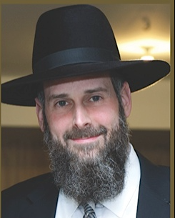

**Rabbi Yosef Viener**

Rabbi Viener explained that the Menorah also symbolizes the Torah and it also represents the concept of eternity. Each morning the Kohanim (the priests) would reassemble and reconstruct the Menorah which was an ongoing activity unlike the inauguration offering of the Nasiim (the leaders) of the non-Levitical tribes which was a one-time activity.

Similarly the study of Torah that as mentioned before is symbolized by the Menorah is not a one-time function. Rabbi Viener emphasized that you never finish studying Torah. If you review a particular section of the Torah that you have already learned, you will continually come away with incredible new insights that you didn’t perceive when you first or last learned that part of the Torah.

We all know that there is a mitzvah to perform yibum, a levirate marriage. This is usually done by the brother of a man who died without having children from his wife. The brother-in-law marries his brother’s wife and that is the mitzvah of yibum in order to produce children to perpetuate his dead brother’s memory. If the brother-in-law refuses to fulfill the mitzvah of yibum he has to carry out the ritual of chalitzah, which is a type of divorce that allows his dead brother’s widow to remarry someone else. Today we Ashkenazi Jews are accustomed to just performing chalitzah.

**Other Relatives Can Also**

**Perform the Mitzvah of Yibum**

In the past when it was more common to fulfill the actual yibum mitzvah, if a direct brother of the deceased was not available, another relative (i.e. an uncle or a cousin) could perform the yibum, even though it is not a direct mitzvah or obligation on the relative (as was the case with Boaz in Megillas Esther) who is not an actual brother-in-law of the childless widow.

Rabbi Viener offered that had Boaz asked him for his psak (rabbinical opinion) as to whether or not he should carry out the mitzvah of yibum with Ruth, he (Rabbi Viener) would probably have advised Boaz with seven reasons why he shouldn’t do it.

Why does Boaz need to perform this mitzvah which he technically was not obligated to carry out? Boaz was the shofet (judge and leader) of Klal Yisroel (the Jewish nation). Why take the risk that people will say that one isn’t allowed to marry a Moabite gairess (convert) and that any of his descendants would have a dubious status of mamzerus (not being regarded as pure Jews). Indeed, later on Yeshai (Jesse), the grandson of Boaz decided that his grandfather’s yibum with Ruth was not proper.

However, Boaz realized that if this opportunity to perform the mitzvah of yibum came his way, than this was the ratzon (will and desire) of Hakodesh Baruch Hu and Boaz was quick to grasp this opportunity even though he realized that he was an old man and was going to die shortly. Rabbi Viener explained that Boaz did not lose out. Indeed he was probably destined to pass away a week or two earlier, but because he understood that this mitzvah was what Hakodesh Baruch Hu wanted him to perform, he was granted an extra week or two of life in order to fulfill the ratzon of Hashem.

**The Maharal Teaches the True Definition of Spiritual Heroism**

The Maharal teaches that the true definition of gevurah (strength) is when one confronts a challenge and overcomes his yetzer hora (evil inclination) in order to perform the right thing that the Torah commands one to do. Likewise if one is simcha b’chelka (happy with his lot in life) that is the true definition of one who is according to the Torah truly wealthy.

One has to realize that one must not worry about what other people are saying or doing if it prevents you from doing your own avodas Hashem (divine service). People claim that they set out each morning to daven (pray) with kavana (concentration) or to learn a seder (schedule) of Torah each day. They wonder why they have trouble focusing on this avodas Hashem.

***Recognizing the Strategy***

***Of Yetzer Hora***

The Vilna Gaon says that one has to struggle with the concept of realizing that this is the strategy of the yetzer hora to foil your noble intentions. There are those who in this past year have declared with regards to the struggle to eliminate the deathly threat of the Corona virus that “Science will win!”

Rabbi Viener declared that such an attitude is kefirah (heresy or disbelief in the power of Hakodesh Baruch Hu). Science is certainly a useful tool that Hashem has given us to make our lives better. But to think that this will be our salvation is absolutely dripping with kefirah. This is nothing other than a desire by man to be in control of everything and deny his need to rely on Hashem’s chesed (kindness). The true simcha (joy) for a Jew is to have a 24/7 conenction to Hakodesh Baruch Hu

*Reprinted from the June 24, 2021 edition of The Flatbush Jewish Journal.*

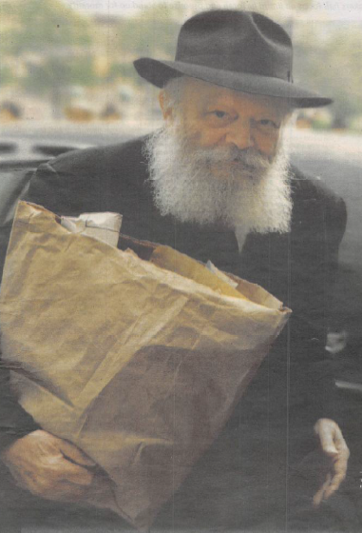

**The Lubavitcher Rebbe (Rabbi Menachem Mendel Schneerson, zt”l) holding a bag of kvitlach on one of his hundreds of prayer visits to the kever of his father-in-law at the Old Montifiore Cemetery in Queens, NY.**